Course Project Report on
“Graph Arithmetic Explorer”
SUBMITTED IN PARTIAL FULFILLMENT OF THE REQUIREMENTS FOR THE DEGREE OF
BACHELOR OF TECHNOLOGY IN
“Computer Science and Engineering (Artificial Intelligence)”

OF
VISHWAKARMA INSTITUTE OF TECHNOLOGY

Savitribai Phule Pune University

Sakshi Auti (12310201)
Pranav Bagade (12311134)
Gaurang Wankhade (12311287)
Aditya Kulkarni (12311055)
UNDER THE GUIDANCE OF
“Prof. Shraddha Mankar”


DEPARTMENT OF ENGINEERING SCIENCES AND HUMANITIES

BANSILAL RAMNATH AGARWAL CHARITABLE TRUST’S
VISHWAKARMA INSTITUTE OF TECHNOLOGY
(An Autonomous Institute affiliated to Savitribai Phule Pune University)

2025 – 2026
BANSILAL RAMNATH AGARWAL CHARITABLE TRUST’S

VISHWAKARMA INSTITUTE OF TECHNOLOGY
(An Autonomous Institute affiliated to Savitribai Phule Pune University)

PUNE – 411037

CERTIFICATE

This is to certify that the Course Project titled “Graph Arithmetic Explorer” submitted by Sakshi Auti (12310201), Pranav Bagade (12311134), Gaurang Wankhade (12311287), Aditya Kulkarni (12311055) is in partial fulfillment for the award of Degree of Bachelor of Technology in Computer Science and Engineering (Artificial Intelligence) of Vishwakarma Institute of Technology, Savitribai Phule Pune University. This project report is a record of bonafide work carried out by him under my guidance during the academic year 2025-26.

Guide HOD
Prof. Shraddha Mankar Prof. Dr. Nilesh P. Sable

Place: VIT, Pune
Date:

Bansilal Ramnath Agarwal Charitable Trust’s

Vishwakarma Institute of Technology, Pune-37
Department of “Computer Science and Engineering (Artificial Intelligence)”

PROJECT SYNOPSIS

Group No : 2
Members: 4
Roll No. | G.R.No. | Name of Student | Contact No. | Email ID
10 | 12310201 | Sakshi Auti | 7219039132 | sakshi.auti23@vit.edu
13 | 12311134 | Pranav Bagade | 7709380448 | pranav.bagade23@vit.edu
34 | 12311287 | Gaurang Wankhade | 9422078126 | gaurang.wankhade23@vit.edu
58 | 12311055 | Aditya Kulkarni | 7821001928 | aditya.kulkarni231@vit.edu

Academic Year : 2024 - 2025
Project Title : Graph Arithmetic Explorer
Project Area : Design and Analysis of Algorithms
Internal Guide : Prof. Shraddha Mankar

Signature of Internal Guide

Introduction

In the field of computer science, graphs are one of the most widely used data structures because they can represent real-world relationships such as transportation networks, communication systems, and social connections. Many important algorithms — like shortest path, traversal, and minimum spanning tree — are built on graphs. However, understanding how these algorithms work internally can be challenging for students, as the process often involves multiple steps, data updates, and logical transitions that are not easy to visualize from code alone.

The Graph Algorithm Explorer project aims to make this learning process simple, interactive, and visually intuitive. It is a web-based interactive visualization tool that allows users to construct graphs, run various algorithms on them, and observe their working in real time. The system demonstrates how different algorithms explore nodes, select edges, calculate weights, and form optimal paths.
Purpose and Motivation

The main purpose of this project is to bridge the gap between theoretical understanding and practical visualization of graph algorithms. While textbooks and lectures explain algorithm logic, learners often struggle to imagine how data flows through nodes or how decisions are made at each step. By representing these processes visually, the project helps users to clearly understand how each algorithm works internally and compare their efficiency.

Another motivation behind this project is to create an educational tool that can assist students, teachers, and researchers in studying algorithms more effectively. Visualization promotes deeper understanding, reduces cognitive load, and makes learning enjoyable and interactive.

Key Features
- Graph Builder Panel – Allows users to create and customize graphs by adding or deleting nodes and edges, defining edge weights, and choosing between directed or undirected graphs.
- Graph Visualization Panel – Displays the graphical representation of the user-created graph and dynamically visualizes the algorithm’s execution process.
- Algorithm Setup Panel – Lets users choose from a list of popular algorithms such as:
  - Breadth-First Search (BFS)
  - Depth-First Search (DFS)
  - Dijkstra’s Algorithm
  - Bellman-Ford Algorithm
  - Prim’s and Kruskal’s Algorithms
  - Floyd-Warshall Algorithm
Users can also adjust parameters such as start and target nodes or animation speed.
- Algorithm Status Panel – Displays detailed information like time complexity, number of vertices and edges, execution steps, total operations performed, and final results.
- Performance Comparison – Users can run multiple algorithms on the same graph to compare their performance and outcomes side by side.

Technologies Used
The project is built using modern web technologies:
- HTML5 for structuring the user interface
- TailwindCSS for responsive and visually appealing styling
- JavaScript (ES6) for implementing the core logic and interactivity
- Canvas API for dynamic graph drawing and animations
Together, these technologies make the application lightweight, efficient, and easily deployable on any browser without additional installations.
Working Overview
When the user launches the application, they can use the Graph Builder to create a network of nodes and edges. Once the graph is ready, an algorithm (like Dijkstra or BFS) can be selected. The system then animates each step of the algorithm — highlighting the currently visited nodes, explored edges, shortest paths, and computed results.
Throughout this process, the Algorithm Status section displays details like the number of steps, time complexity, and operations count. This real-time feedback helps users visually understand how each algorithm progresses and reaches its final solution.

Educational Importance
This project provides a valuable learning experience for both developers and users. For developers, it enhances understanding of algorithm design, data structures, and event-driven programming. For learners, it acts as a visual guide that strengthens conceptual clarity, helping them grasp how algorithmic decisions are made during traversal and optimization.

Codes of main modules used in project

1.Graph Representation and Data Structures
This part stores nodes, edges, and graph-related data structures.

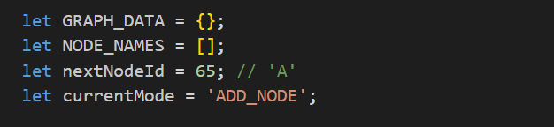
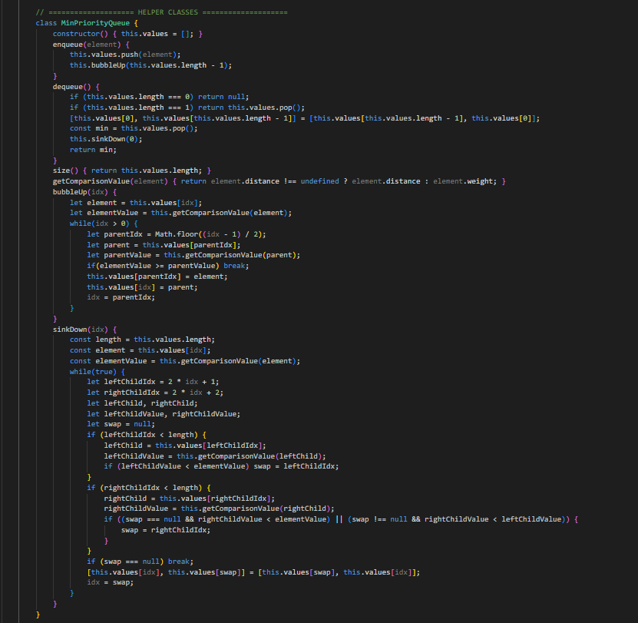
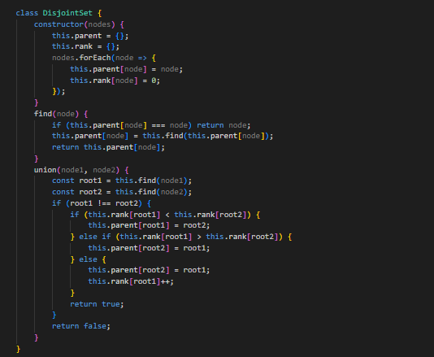

Explanation:
- GRAPH_DATA and NODE_NAMES store all nodes and their edges.
- MinPriorityQueue helps in algorithms like Dijkstra and Prim’s.
- DisjointSet is used for Kruskal’s algorithm to detect cycles efficiently.

2.Graph Drawing and Interaction Module
This part handles canvas drawing, user interaction (adding nodes/edges), and visual feedback.

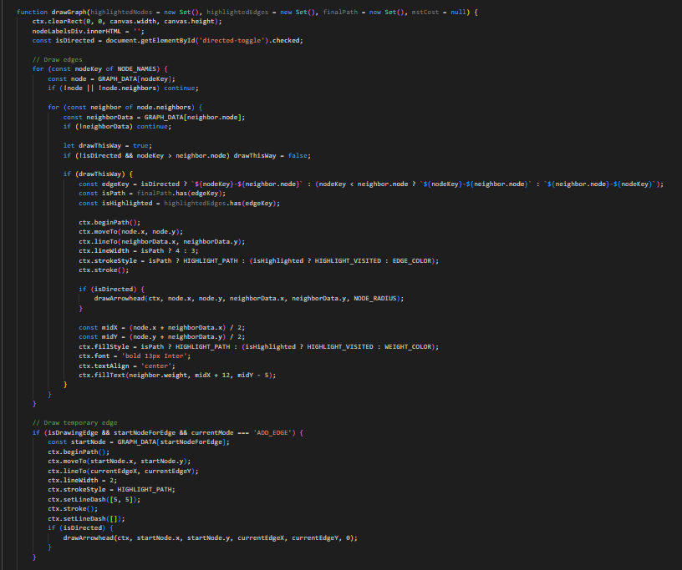
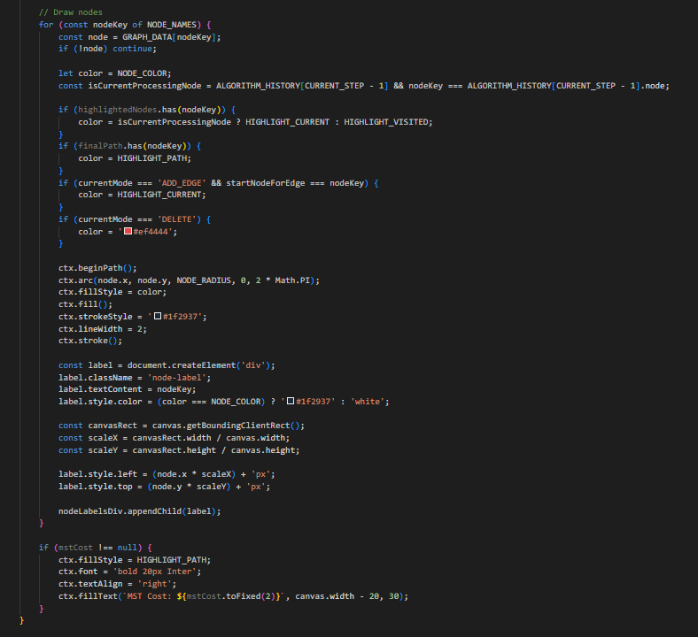
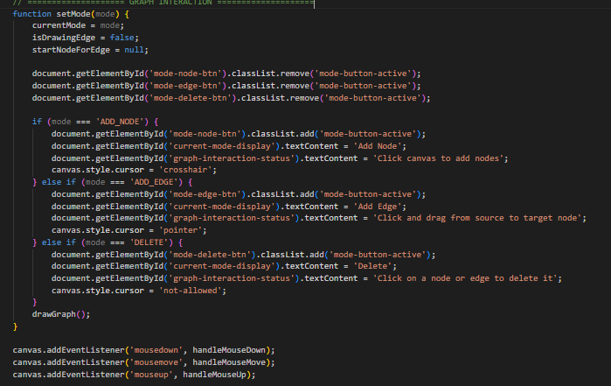
function handleMouseDown(event) { /* Adds node or starts drawing edge */ }
function handleMouseMove(event) { /* Draws temporary edge line */ }
function handleMouseUp(event) { /* Finishes adding edge */ }

function setMode(mode) {
// Switches between Add Node, Add Edge, and Delete modes
drawGraph();
}

Explanation:
- Draws graph elements dynamically on canvas.
- Supports interactive actions like adding, deleting, or connecting nodes visually.
- Uses HTML canvas APIs (ctx.arc, ctx.lineTo, ctx.stroke) for rendering.

3.Graph Analysis and Utility Module
This section calculates graph properties and metrics.
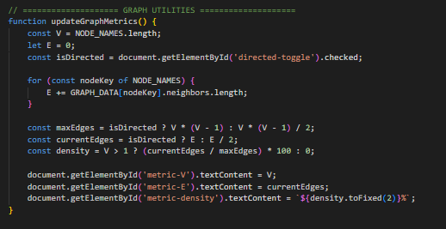
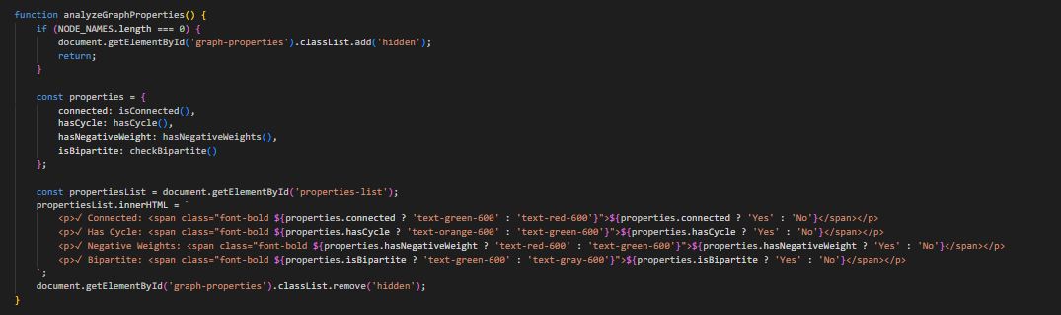

Explanation:
- Computes metrics like number of vertices, edges, and graph density.
- Determines graph characteristics such as connectivity, cycle presence, bipartiteness, etc.

4.Algorithm Modules

Each algorithm is written as an independent function.
They all generate a history of steps for visualization.

- BFS / DFS
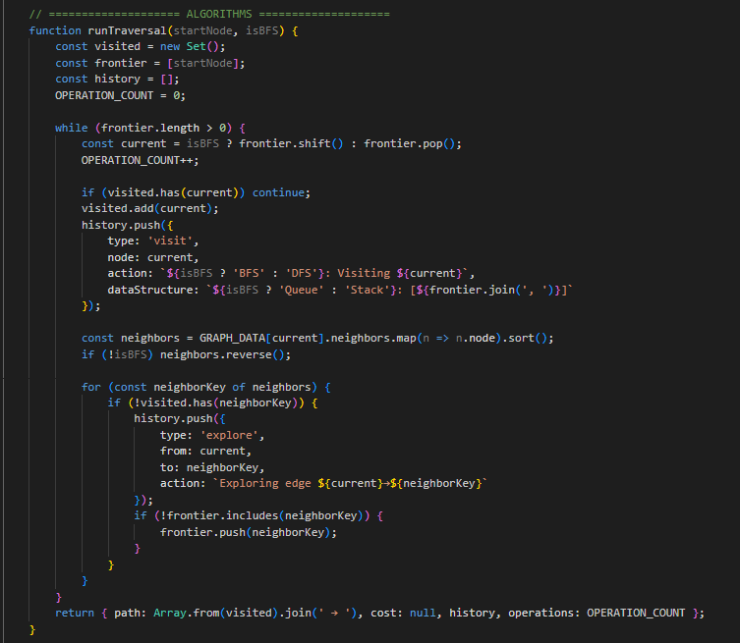

(b) Dijkstra’s Algorithm
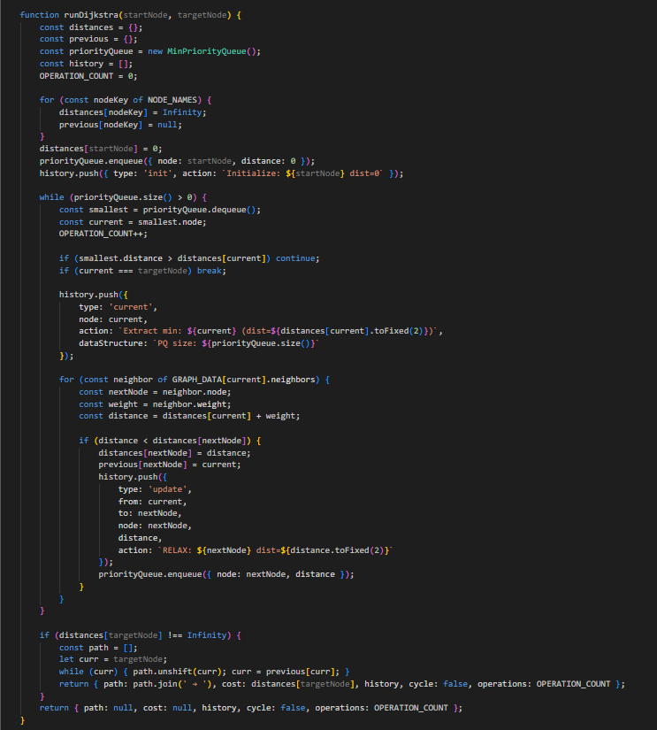 (c) Bellman-Ford
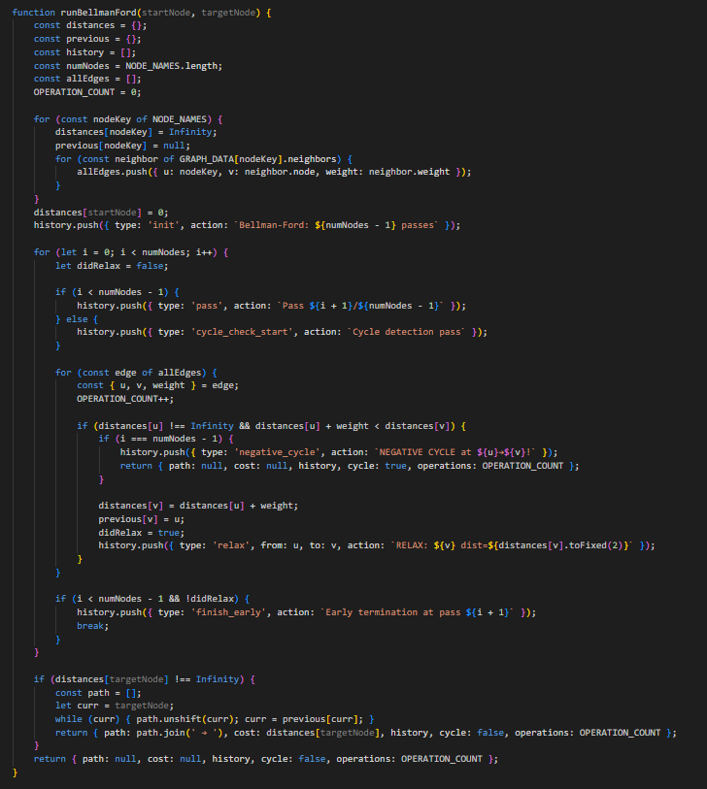 (d) Prim’s and Kruskal’s (MST Algorithms)
- Prim’s uses a MinPriorityQueue to grow the MST.
- Kruskal’s uses the DisjointSet for cycle detection and union-find.

5.Visualization Controller Module

Handles user commands and visualization playback.
function startVisualization() {
const algo = document.getElementById('algorithm-select').value;
const start = document.getElementById('start-node').value;
let result;
if (algo === 'BFS') result = runTraversal(start, true);
else if (algo === 'Dijkstra') result = runDijkstra(start, target);
// ...
drawStep();
}
Explanation:
- Connects UI elements (buttons, dropdowns) to algorithm execution.
- Displays algorithm progress step-by-step or auto-plays it.
- Highlights nodes, edges, and pseudocode lines dynamically.

Screenshots of results

Screenshot
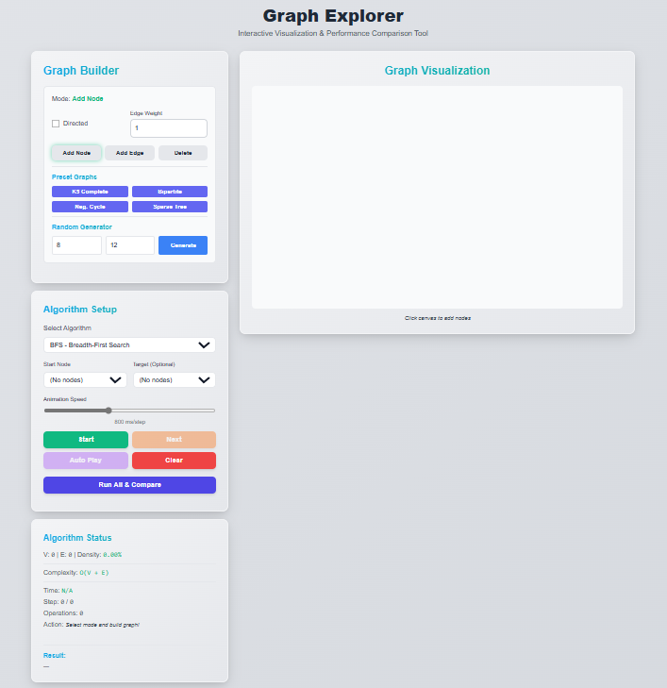
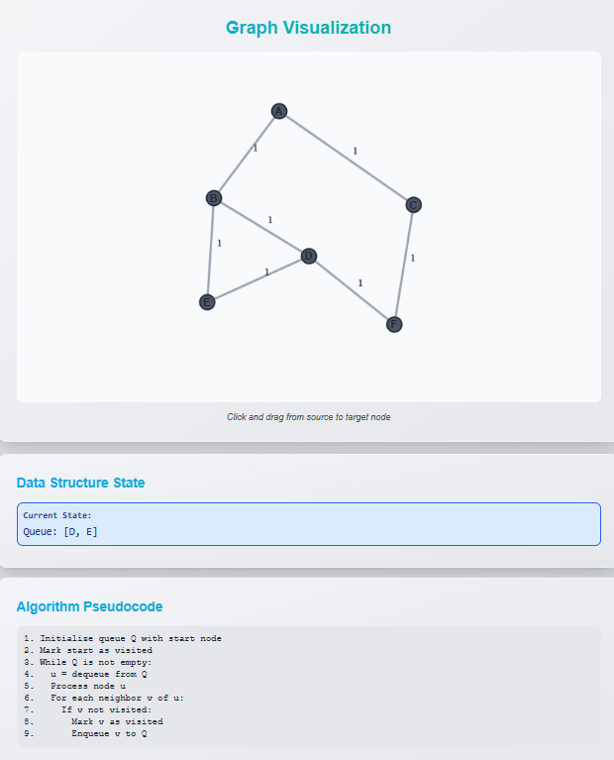
The interface is divided into four main sections:
- Graph Builder
- Algorithm Setup
- Graph Visualization
- Algorithm Status

1. Graph Builder
This section allows users to create and customize graphs manually or automatically.

Features:
- Mode Selector:
Choose between “Add Node”, “Add Edge”, or “Delete” modes to interact with the canvas.
- Directed Checkbox:
Option to make the graph directed or undirected.
- Edge Weight Field:
Enter a numeric value to assign weights to edges.
- Buttons:
  - Add Node – Adds a new node on the canvas.
  - Add Edge – Connects two nodes with the specified weight.
  - Delete – Removes nodes or edges.
- Preset Graphs:
Quickly generate sample structures like:
  - K5 Complete Graph
  - Bipartite Graph
  - Ring/Cycle Graph
  - Spanning Tree
- Random Generator:
Generate a graph with a custom number of nodes and edges automatically.
Purpose:
This helps learners experiment with different graph structures before applying algorithms.

2. Algorithm Setup
This panel lets users choose and configure the graph algorithm to visualize.
Components:
- Algorithm Dropdown:
Select from available algorithms such as:
  - BFS (Breadth-First Search)
  - DFS (Depth-First Search)
  - Dijkstra’s Shortest Path
  - Prim’s or Kruskal’s for MST
- Start & Target Nodes:
Choose which node to begin from, and optionally, which to target (for shortest path algorithms).
- Animation Speed Slider:
Controls how fast or slow the visualization runs.
- Control Buttons:
  - Start – Begin algorithm visualization.
  - Next – Step through each iteration manually.
  - Auto Play – Automatically run the algorithm animation.
  - Clear – Reset the graph and clear results.
  - Run All & Compare – Execute multiple algorithms and compare their performance metrics.
Purpose:
This makes learning algorithms interactive — users can see the internal process in real time.

3. Graph Visualization
This is the central canvas area where the graph is displayed and animated.
Description:
- Canvas Display:
Nodes are represented as circles and edges as connecting lines.
- Interactive Behavior:
  - Click to add or select nodes.
  - Drag to connect nodes.
  - Watch algorithm animations (like node traversal, edge selection, etc.).
- Status Text:
A small message below the canvas shows hints like “Click canvas to add nodes.”
Purpose:
Provides visual understanding of how algorithms traverse, visit, or update nodes and edges.

4. Algorithm Status
This section displays real-time updates and performance metrics during visualization.
Information Shown:
- Graph Properties:
  - Number of vertices (V)
  - Number of edges (E)
  - Density
  - Directed or undirected
- Algorithm Complexity:
Displays Big-O notation (like O(V + E)).
- Execution Stats:
  - Current step number
  - Operations performed
  - Time taken
- Result Output:
Shows final results such as traversal order, shortest path, or minimum spanning tree edges.
Purpose:
This helps learners compare performance and complexity of algorithms on the same dataset.

User Flow Summary
- Build the graph manually or using presets.
- Choose an algorithm and configure parameters.
- Visualize step-by-step execution or auto-run it.
- Observe results and complexity in the Algorithm Status panel.

Conclusion

The Graph Algorithm Explorer project effectively demonstrates how visualization can make the learning and analysis of algorithms more interactive and engaging. By presenting a clear graphical representation of how algorithms traverse nodes, calculate weights, and determine optimal paths, the tool simplifies complex concepts into understandable visual steps.

Through this platform, users can experiment with various graph types — directed, undirected, weighted, or random — and immediately observe algorithmic behavior and results. This helps learners not only grasp algorithm logic but also understand efficiency, time complexity, and performance variations.

In conclusion, this project bridges the gap between theoretical learning and practical understanding. It serves as a valuable educational aid for students studying Data Structures and Algorithms (DSA) and can be further enhanced by integrating more algorithms, dynamic animations, and real-world applications such as network routing simulations or AI pathfinding.

Overall, the Graph Algorithm Explorer provides a meaningful and visual way to explore how algorithms work — turning complex theory into an interactive and engaging learning experience.

References

- Thomas H. Cormen, Charles E. Leiserson, Ronald L. Rivest, and Clifford Stein,
Introduction to Algorithms, 3rd Edition, MIT Press, 2009.
(For understanding algorithm design and graph theory concepts.)

- Narasimha Karumanchi,
Data Structures and Algorithms Made Easy, CareerMonk Publications, 2017.
(For clear explanation and pseudocode of BFS, DFS, Dijkstra, and MST algorithms.)

- GeeksforGeeks,
https://www.geeksforgeeks.org/graph-data-structure-and-algorithms/
(Used for understanding and verifying algorithm implementations and edge cases.)

- JavaScript MDN Web Docs,
https://developer.mozilla.org/en-US/docs/Web/JavaScript
(For reference on JavaScript syntax, canvas API, and event handling.)

- Tailwind CSS Documentation,
https://tailwindcss.com/docs
(For designing and styling the frontend interface.)

- W3Schools,
https://www.w3schools.com/js/
(For learning DOM manipulation, input handling, and responsive layout design.)

- YouTube Tutorials – Graph Algorithm Visualization,
(For ideas on visual representation and animation of graph algorithms.)

- Stack Overflow Community,
https://stackoverflow.com
(For debugging issues related to canvas rendering and event handling.)

